

**REPUBLIC OF CAMEROON**

**PEACE-WORK-FATHERLAND**

**UNIVERSITY OF BUEA**

**BUEA, SOUTH-WEST REGION**

**P.O BOX 63.**

**RÉPUBLIQUE DU CAMEROUN**

**PAIX-TRAVAIL-PATRIE**

**UNIVERSITÉ DE BUEA**

**BUEA, RÉGION DU SUD-OUEST**

**B.P. 63.**

**FACULTY OF ENGINEERING**

**FACULTY OF ENGINEERING AND TECHNOLOGY**

**DEPARTMENT OF COMPUTER ENGINEERING**

**SOFTWARE ENGINEERING**

**CEF440: Internet and Mobile Programming**

**DESIGN AND IMPLEMENTATION FOR A DISASTER MANAGEMENT MOBILE APPLICATION (TASK 5)**

**Course Facilitator:**

Dr. NKEMENI Valery, PhD

**Date Issued:**

31st May 2024

**Presented by:**

**GROUP 2**

|  |  |
| --- | --- |
| NAMES | MATRICULE |
| QUINUEL TABOT NDIP-AGBOR | **FE21A300** |
| SIRRI THERESIA ANYE | **FE21A306** |
| NGONCHI RAMATOU YOLAND | **FE21A260** |
| CHE BLAISE NJI | **FE21A157** |
| LIMA CHARLES | **FE21A225** |

**Table of Content**

**1.** **ABSTRACT** 3

**2.** **INTRODUCTION** 3

**3.** **DESIGN PHASE** 3

**3.1.** **PERSONA** 3

**i.** **Admin persona** 4

**ii.** **Emergency Responder** 5

**iii. Civilian (normal user)** 5

**3.2.** **SCENARIOS OF A DISASTER MANAGEMENT MOBILE APPLICATION** 6

**3.3.** **USER JOURNEY MAP** 8

**3.4.** **MAP VISUALISATION THROUGH WIRE FRAMING** 9

**i. Wire framing objects and attributes of the main Screens**. 10

**ii.** **Wire framing sketches** 13

**4.** **IMPLEMENTATION WITH FIGMA.** 14

**i.** **Home screen** 14

**ii.** **Registration/Login** 15

**iii.** **Emergency Responders Contact** 17

**iv.** **Incident reporting.** 18

**v.** **Alerts/Notifications** 19

**vi.** **Setting/Updates** 20

**5.** **CONCLUSION** 20

**6.** **REFERENCES.** 20

# 

# **ABSTRACT**

This design phase outlines the process of creating a disaster management mobile application aimed at providing timely assistance and resources to individuals affected by disasters. Through personas, user journey maps, wireframing, and implementation using Figma, the application seeks to address the diverse needs of users during crisis situations, fostering resilience and community support.

# **INTRODUCTION**

Disasters can strike unexpectedly, causing widespread devastation and leaving individuals in urgent need of assistance. In response to this pressing issue, our team embarked on the design of a mobile application dedicated to disaster management. The application aims to empower users by providing access to essential information, resources, and support networks before, during, and after disasters. In this design phase, we will detail the key steps involved in creating the application, including the development of personas to understand user needs, the creation of user journey maps to visualize the user experience, wireframing to design the application's layout and functionality, and finally, implementation using Figma to bring the concept to life. Through a user-centered approach, we aim to create a comprehensive and intuitive solution that enhances preparedness and response efforts in times of crisis.

# **DESIGN PHASE**

## **PERSONA**

The number of personas in the disaster management mobile application depends on the specific target audience and the scope of the application. However, some common personas that we want to consider include:

* Admin (Disaster management officials): Individuals who are responsible for planning and coordinating disaster response and recovery efforts.
* Emergency responders: Emergency personnel who need to use the app to respond to and manage disasters.
* Civilians: Individuals who are at risk of being affected by disasters and need to be informed and prepared.
* People with disabilities: Individuals who may have specific needs or challenges during a disaster.

We will have a practical example with information of the various users of our system’s persona below

### **Admin persona**

Name: Sarah

* Age: 45
* Occupation: Emergency management director
* Goals: To ensure the safety and well-being of her community before, during, and after disasters.

**•Touchpoints:**

* Disaster management mobile app Emergency response software
* Social media
* Email
* Phone

**Emotions:**

* Stressful: When managing a disaster response, Sarah is under a lot of pressure to make quick decisions and coordinate multiple resources.

* Determined: Sarah is committed to protecting her community and ensuring that they have the resources they need to recover from disasters.

* Grateful: Sarah is thankful for the support of her team and the volunteers who help her to manage disaster response efforts.

**• Pain points**:

* Lack of resources: Sarah often has to make difficult decisions about how to allocate limited resources during a disaster.

* Communication challenges: It can be difficult to communicate with all of the stakeholders involved in disaster response, especially in areas with limited connectivity.

* Public resistance: Sarah sometimes encounters resistance from the public when implementing disaster preparedness measures or evacuations.

### **Emergency Responder**

• Name: John

• Age: 30

• Occupation: Firefighter/paramedic

• Goals: To save lives and property during disasters.

**Touchpoints:**

* Disaster management mobile app

* Emergency response vehicle

* Radio

* Flashlight

* Medical equipment

**• Emotions:**

* Fearful: John is often exposed to dangerous situations when responding to disasters.

* Adrenaline-fueled: John gets a sense of adrenaline and excitement when responding to emergencies.

* Compassionate: John cares deeply about helping others and making a difference in their lives.

• **Pain points:**

* Lack of information: John sometimes lacks access to real-time information about the disaster situation, which can make it difficult to make decisions.

* Limited resources: John often has to work with limited resources, which can make it difficult to provide the best possible care to victims.

* Physical and emotional exhaustion: Disaster response work can be physically and emotionally demanding, and John often has to work long hours in difficult conditions.

### **iii. Civilian (normal user)**

• Name: Mary

• Age: 50

• Occupation: Teacher

• Goals: To keep herself and her family safe during a disaster.

**• Touchpoints:**

* Disaster management mobile app

* Social media

* Television

* Radio

**• Emotions:**

* Anxious: Mary is worried about the safety of her family and her community during a disaster.

* Confused: Mary may not always understand the instructions or information that is provided during a disaster.

* Grateful: Mary is thankful for the help and support of her community during a disaster.

• **Pain points:**

* Lack of information: Mary may not have access to accurate or timely information about the disaster situation, which can make it difficult to make decisions.

* Communication challenges: Mary may have difficulty communicating with her family and friends during a disaster, especially if there is limited connectivity.

* Lack of preparedness: Mary may not have the necessary supplies or knowledge to prepare for a disaster.

By understanding the personas, touchpoints, emotions, and pain points of our target users, we can design a disaster management mobile application that meets their needs and helps them to prepare for, respond to, and recover from disasters.

## **SCENARIOS OF A DISASTER MANAGEMENT MOBILE APPLICATION**

**Scenario 1: Registration/Login**

- User downloads and opens the disaster management app

- Login if has an account, if not.

- Prompted to create an account for access to emergency resources and information

- Enters email address, creates a password, and provides basic personal information

- Clicks "Register"

- Receives a verification email

- Clicks verification link in the email to confirm their email address

- Redirected back to the app and prompted to log in with their email and password

- Enters credentials and clicks "Login"

- Gains access to real-time alerts, emergency resources, and communication tools

**Scenario 2: Preparedness Before a Disaster**

• User receives notifications about potential threats and prepares an emergency plan.

• User identifies nearby shelters, evacuation routes, and resource centers using the app.

• User shares their emergency contact information and medical history with trusted individuals.

**Scenario 3: Alerts/Notifications During a Disaster**

• User receives real-time emergency alerts and updates on the disaster's progress.

• User uses the app to navigate evacuation routes and find the nearest shelter.

• User communicates with family and friends using the app's messaging or social media integration.

**Scenario 4: After a Disaster (recovery)**

• User uses the app to locate nearby resources such as food banks, medical facilities, and counselling services.

• User connects with other survivors and volunteers to offer or receive assistance.

• User provides feedback on the disaster response and recovery efforts through the app.

**Scenario 5: User with Disabilities**

• User with visual impairment uses the app's screen reader functionality to access information and navigate the interface.

• User with hearing impairment uses closed captions for videos and text-based alerts.

• User with cognitive disabilities uses simplified language and clear visual cues to understand the app's functionality.

**Scenario 6: User in a Remote Area (offline functionality)**

• User with limited internet connectivity downloads essential data and resources offline before a disaster strikes.

• User uses the app's offline maps and GPS functionality to navigate evacuation routes.

• User communicates with emergency services via text messaging or satellite connection.

**Scenario 7: Emergency Responders**

Emergency Responders uses the app to access real-time disaster information, including incident reports and resource availability.

• Emergency Responders uses the app to communicate with other responders and coordinate relief efforts.

• Emergency Responders uses the app to document and share damage assessments.

**Scenario 8: Incident Reporting**

• User witnesses a disaster event and uses the app to report it to emergency services.

• User provides details about the incident, including location, type of disaster, and severity.

• User attaches photos or videos as evidence to support the report.

• Emergency services receive the report and dispatch responders accordingly.

• User receives updates on the incident's status and response efforts through the app.

**Scenario 9: Settings and Updates**

• User customizes the app's settings to receive alerts for specific disaster types and locations.

• User sets up emergency contacts and shares their location with trusted individuals.

• User enables offline functionality to ensure the app can be used even without internet connectivity.

• User receives notifications about app updates and new features.

• User provides feedback on the app's functionality and suggests improvements.

## **USER JOURNEY MAP**

Based on the above Personas and various Scenarios, we now develop the user journey map of our system.

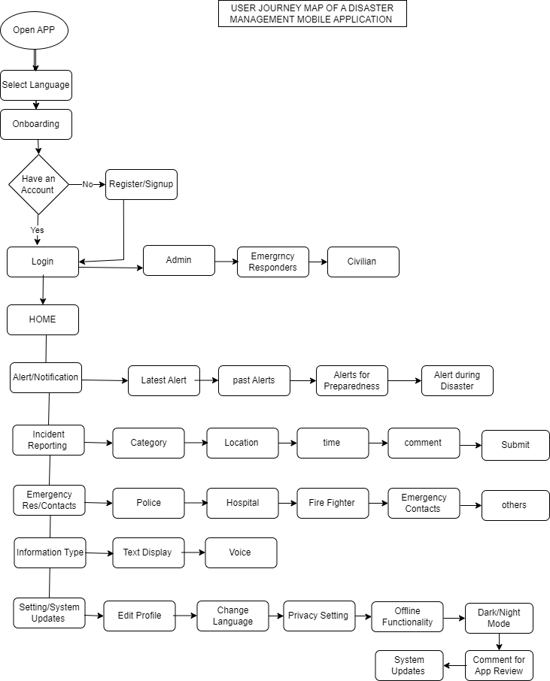

## **MAP VISUALISATION THROUGH WIRE FRAMING**

Based on the above user flow chart, the following main Screens are to be consider, which in return pops up or drop down other sub-screens, depending on the user’s perspectives and wants.

## **i. Wire framing objects and attributes of the main Screens**.

1. open App Onboarding Screen Wireframe:

———————————-

[Logo]

[ select language]

[Title: ]

[ welcome Field]

[introduction to features]

2. Registration Screen Wireframe:

———————————-

[Logo]

[Title: Create Account]

[category of user]

[Email Address Input Field]

[Password Input Field]

[Confirm Password Input Field]

[First Name Input Field]

[Last Name Input Field]

[Phone Number Input Field]

[Register Button]

3. Verification Email Screen Wireframe:

———————————-

[Logo]

[Title: Verify Your Email]

[Instructional Text: Please check your email and click the verification link to complete the registration process.]

[Resend Verification Email Button]

3. Login Screen Wireframe:

———————————-

[Logo]

[Title: Log In]

[category of user]

[Email Address Input Field]

[Password Input Field]

[Forgot Password Link]

[Login Button]

4. Home Screen Wireframe

———————————-

[Logo]

[Title: home]

[alerts]

[Report Incident]

[Emergency Responders contacts]

[type of message]

[setting/updates]

5. Preparedness Before a Disaster Wireframe:

———————————-

[Logo]

[Title: Preparedness Before a Disaster]

[Checklist of Preparedness Items]

[Emergency Contact Information Input Fields]

[Emergency Kit Checklist]

[Evacuation Plan Input Field]

[Save and Update Button]

6. Alerts and Notifications During Disaster Wireframe:

———————————-

[Logo]

[Title: Alerts and Notifications]

[Map with Disaster Location and Affected Areas]

[Emergency Alert Notifications]

[Weather Updates]

[Shelter Locations and Availability]

[Emergency Contacts Information]

7. Recovery After a Disaster Wireframe:

———————————-

[Logo]

[Title: Recovery After a Disaster]

[Recovery Resources and Services]

[Community Support Information]

[Insurance Claim Filing Assistance]

[Rebuilding Checklist]

[Support Group Information]

8. Offline Capabilities Wireframe:

——————————-

[Logo]

[Title: Offline Capabilities]

[Offline Mode Toggle Switch]

[Downloadable Emergency Resources]

[Offline Access to Emergency Contacts]

[Saving Incident Reports Locally]

9. Emergency Responders Wireframe:

———————————-

[Logo]

[Title: Emergency Responders]

[Select Emergency Responders needed]

[Emergency Services Contact Information]

[Request Assistance Button]

[Location Sharing with Responders]

[Real-time Communication with Responders]

10. Incident Reporting Wireframe:

———————————-

[Logo]

[Title: Incident Reporting]

[Incident Type Selection]

[Location Tagging, time]

[Description of Incident Input Field]

[Upload Image/Video Evidence]

[Submit Report Button]

11. Settings and Updates Wireframe:

———————————-

[Logo]

[Title: Settings and Updates]

[Profile Information Update Fields]

[Notification Settings]

[Language Selection Option]

[App Version Update Notification]

These wireframes provide a basic structure for the various features of the disaster management app. we further enhance them with visual elements, branding, and additional features as needed.

## **Wire framing sketches**

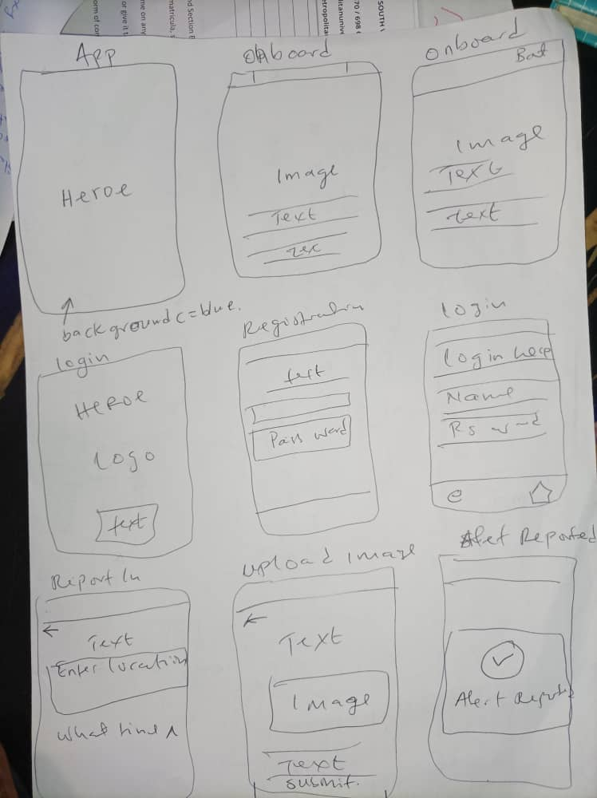

Using the 10 design principles, which are: simplicity, consistency, Hierarchy, Balance, Emphasis, unity, contrast, Functionality, Accessibility, Feedback, and the user centered design, we use colours and images in their appropriate positions, and backgrounds.

# **IMPLEMENTATION WITH FIGMA.**

## **Home screen**

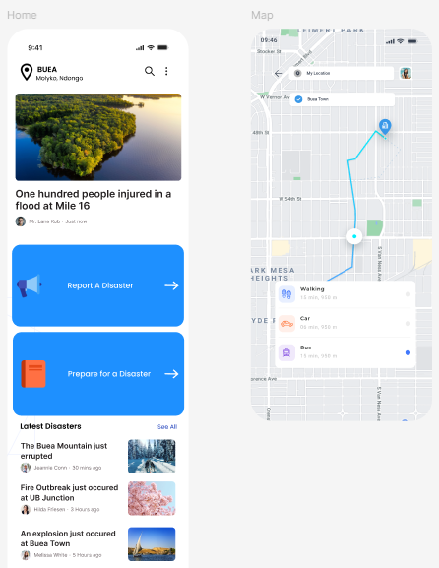

## **Registration/Login**

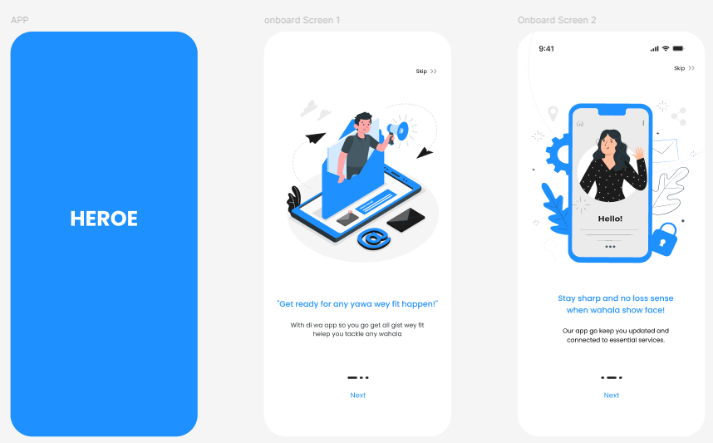

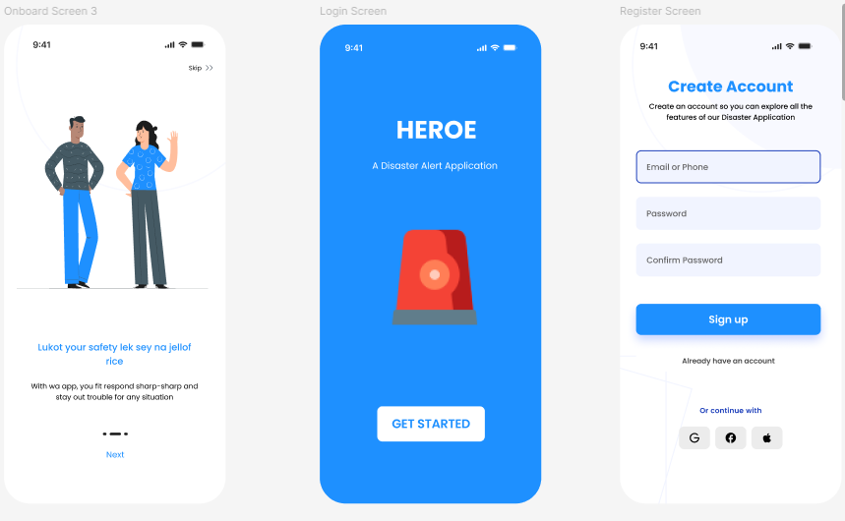

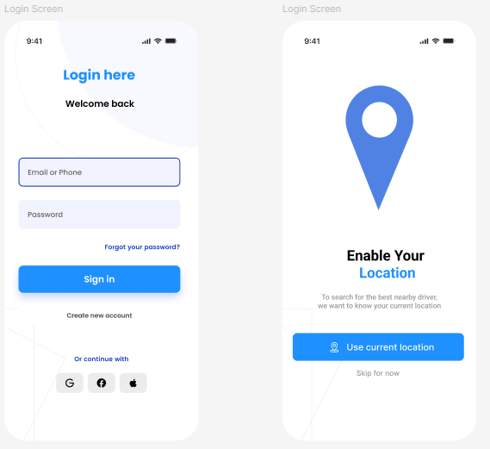

## **Emergency Responders Contact**

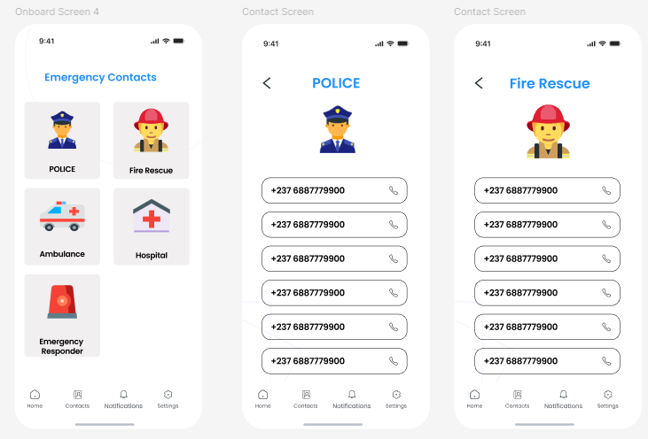

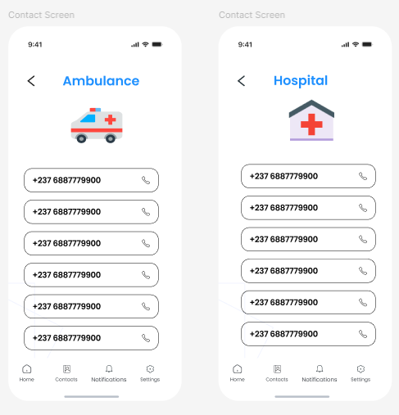

## **Incident reporting.**

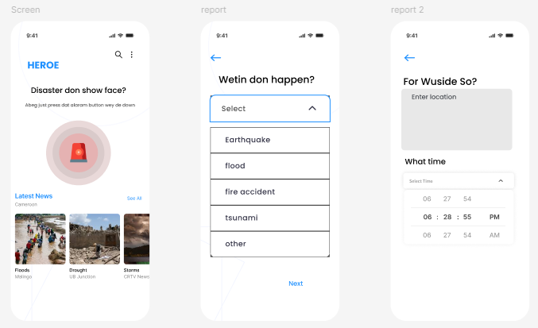

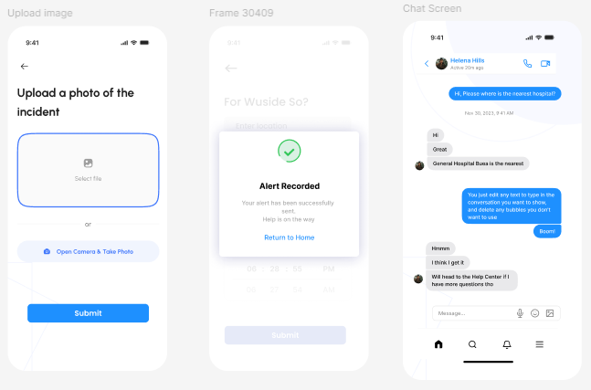

## **Alerts/Notifications**

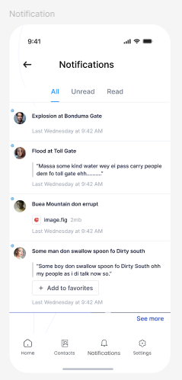

## **Setting/Updates**

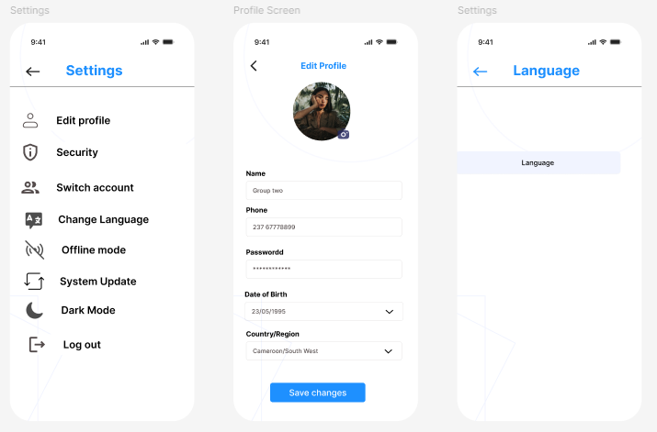

# **CONCLUSION**

The design of the disaster management mobile application is based on a thorough understanding of the needs of users, as identified through user research, personas, scenarios, and a user journey map. The application is designed to be easy to use, accessible to all users, and effective in helping users to prepare for, respond to, and recover from disasters.

We plan to continue to develop and improve the application based on feedback from users and stakeholders. We are committed to making the application as user-friendly and effective as possible.

# **REFERENCES.**

[**https://www.figma.com/design/Ud6Hh9suPpsFRma0GNVRdZ/H%C3%A9roe?node-id=0-1&t=KKhJFXQIBiqZTXNN-0**](https://www.figma.com/design/Ud6Hh9suPpsFRma0GNVRdZ/H%C3%A9roe?node-id=0-1&t=KKhJFXQIBiqZTXNN-0)